European Disability and Development Week 2018

Together for Inclusion | Leave No One Behind
December 3-10, 2018
PHOTO CONTEST
APPLICATION OPEN UNTIL 6 JANUARY 2019
For the 3rd time, IDDC will organise the European Disability and Development Week, starting with the International Day of Persons with Disabilities (December 3rd) and concluding a week later on Human Rights Day (December 10th).
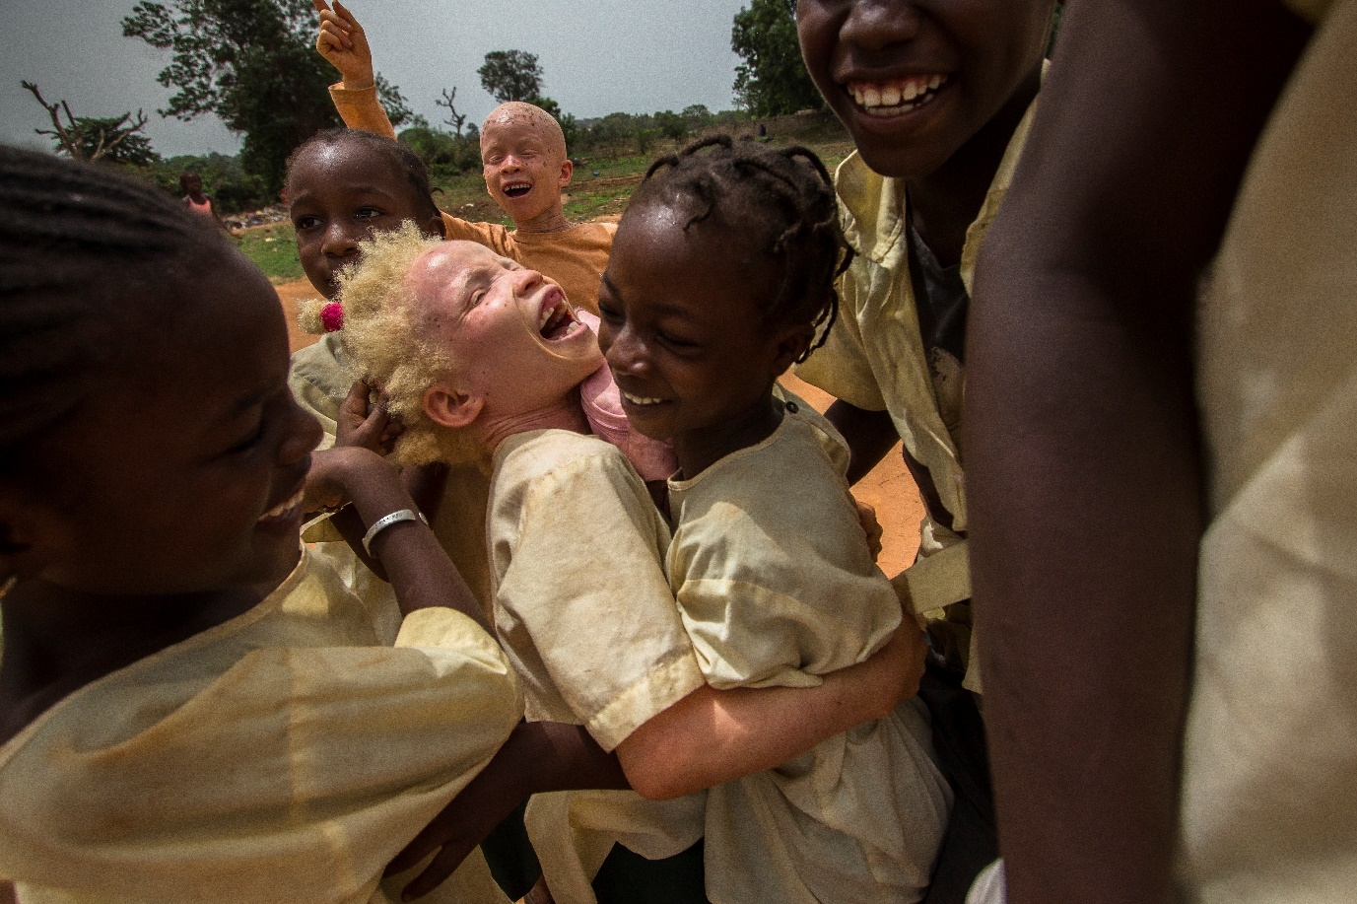
#EDDW18 has 3 objectives

- Showcase the breadth and variety of disability inclusion in international development

- Encourage solidarity and participation across Europe for disability inclusion

- Strengthen interaction between decision makers and representatives of persons with disabilities.
  - ‘Aicha and Friends’, taken by Marta Moreiras, winner of the #EDDW17 photo competition

As part of the EDD Week, we are organising a new photo contest!

Objectives of the contest
As part of the 2018 European Disability and Development Week, we are collecting meaningful and beautiful photographs that illustrate the Week’s theme: “Inclusion Together: Leave No One Behind” and that depict a person or persons with disabilities, in the context of middle income countries or low income countries.
The 10 best photographs will be exhibited in the course of 2019, to contribute to raising awareness of the rights of persons with disabilities.

Conditions of participation
This contest is free and open to everyone, the general public and photography professionals. Participant should be an individual and not an organization.
Contest participants have free choice as to the treatment of the subject. Photographs presenting a subject not related to the theme will not be taken into account in the final selection.
Only digital photographs are accepted.
The printing of the photographs is taken care of by the contest organizers.

Submission of photographs
Digital photographs must be sent to eddw@iddcconsortium.net by 6 January 2019.
Each participant can submit a maximum of three photographs.
The name of each file will include the initial of the first name, the name of the participant and the number of the photograph (eg JSmith01, JSmitht02 ...).
Only digital photos of good resolution (high quality picture “300dpi”) are accepted. Photos can be edited and filters applied, however, entries must comprise one image only. Photos that contain more than one image shot separately are not allowed. Entries comprised of photo collages or images with additional elements (watermarks, text, etc.) will be rejected. Photos shot using various methods (i.e. long exposure, stacking) and camera built-in effects are accepted.
Each photograph must come with a short description (350 words maximum), providing information on the place, context and identifying the persons and places visible in the photo.
Each participant must provide the duly completed and signed participation form in Annex.

Selection of the winning photographs
For the final selection, the jury will consist of 3 representatives of IDDC, 1 representative of the European Disability Forum, 1 representative of CONCORD.
The selection of photographs will be based on both their technical quality and their originality. Only one photograph per candidate may be awarded. Ten photographs will be finally selected by the jury, and 1 winner will be designated.
The final ten photographs will be exhibited in Brussels (and in various places in Europe if possible) in 2019.

Implementation of the Rules
The registration commits the participant to the rules of the contest in all its provisions.
Failure to comply with one or more of these provisions will result in exclusion of the participant.
In addition, participants waive all recourse regarding the terms of the contest and its conduct, its results and the distribution of prizes.

Responsibilities of authors and use of photographs
Each participant certifies to be the author of the photographs sent and guarantees to have collected the necessary authorizations of the persons possibly staged in the photography or the owners of the interiors, works, objects or goods photographed.

By entering the competition, participants retain full copyright of their images. However, participants also agree to be bound by Facebook legal terms (https://www.facebook.com/legal/terms).
Participants also grant IDDC the right to make free use of the photographs sent on the occasion of this contest (award-winning and non-award-winning), in particular as part of possible awareness-raising actions, publications, exhibitions ... The names of authors will, in all cases, be mentioned.

Any personal information, including, without limitation, the participant’s name, age, address (including postcode), mobile phone number and/or email address will be used solely in connection with this contest and will not be disclosed to any third party except for the purpose of the contest (including subsequent promotions as stated in these terms and conditions).
Check details on: https://iddcconsortium.net/what-we-do/european-union/european-disability-development-week-2018

For any information, please contact: b.bouniol@hi.org

ANNEX

#EDDW18 Photo Contest

Rights Authorization: copyright owner

I, the undersigned (First name + Last name): ………………………………………………………..……………………………
Living at (full address: street + postcode + town + country): ……………………………………………………………….………………………………………………………………………………………………………………………………………………………… hereby authorize the International Disability and Development Consoritum (IDDC) the perpetual right to use, royalty-free and without limitation, for a period of 10 years starting at the date of signature, in the whole world, the material submitted for the #EDDW18 Photo Contest, including to edit, copy, print, reproduce, distribute, translate, and publicly display or publish any such intellectual property rights, for whatever purpose, in any form or medium, either on IDDC website or elsewhere, for promotional activities or events arranged by IDDC, whether locally or world-wide.

Drawn up in one original copy and executed in ……………………………….., on ………………….. (dd/mm/year)
(Signature preceded by “read and approved”)

Signature: ……………………………………………………………

