Social Media Toolkit: It’s bluedy time, Europe!

The 2024 European elections are closer than we might think! For this purpose, we are launching the biggest European consultation alongside other ocean actors. With the aim of putting ocean protection at the centre of the European agenda, here is a social media kit for you to freely use in order to make our message stronger.
> All the visuals of this social media kit are available here .
> You can also find the campaign logos here.
Please feel free to share these posts and key messages with your own networks and to use the hashtag #BlueUp24 !
Feel free to adapt these post ideas for them to fit in your own organisational guidelines. We thank you all for your support.

Coalition social media handles
Add your organisation’s social media handles in the table below

Organisation | Twitter | Facebook | Instagram
Surfrider Foundation Europe | @surfridereurope | https://www.facebook.com/surfridereurope/ | @surfridereurope
XXX
XXX
XXX

Twitter posts

Option 1/

[ACT NOW] 🌊 If you are worried about the future of #OurOcean, here you have the opportunity to bring your ideas to the EU institutions. Check out the discussions already going on ☞ www.oceanvoice.eu
#BlueUp24 #OceanAction
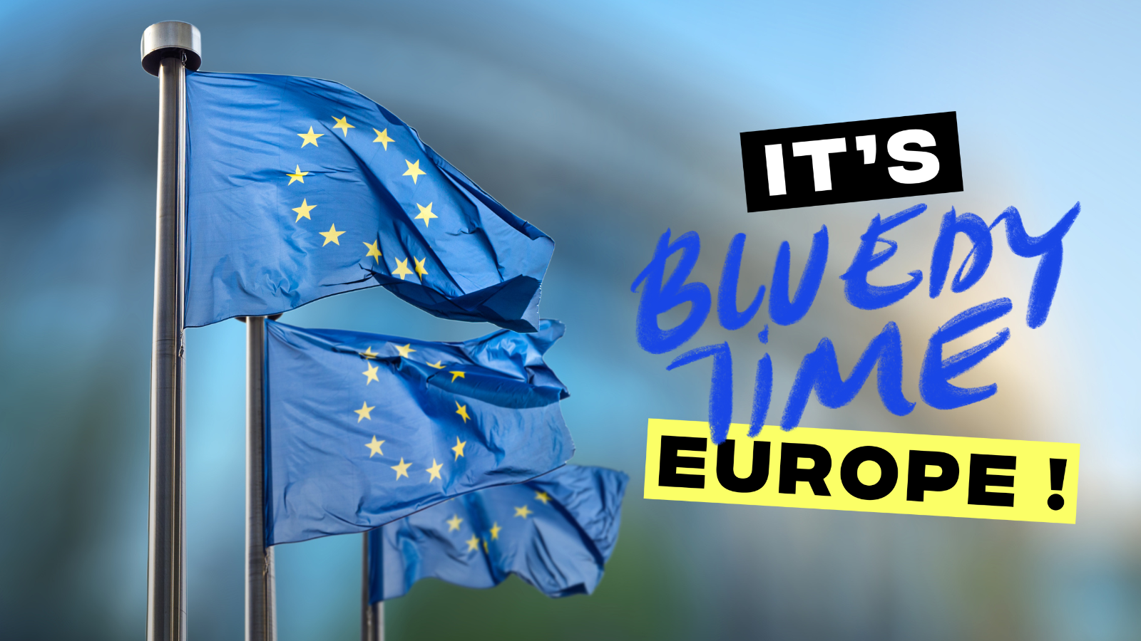

Option 2/
The largest #ocean consultation in Europe is live! 🎉 I already made my contribution on #pollution, but you can also give your ideas on #climatechange, #biodiversity, #blueeconomy or #health🌊 Join the consultation ☞ www.oceanvoice.eu #BlueUp24
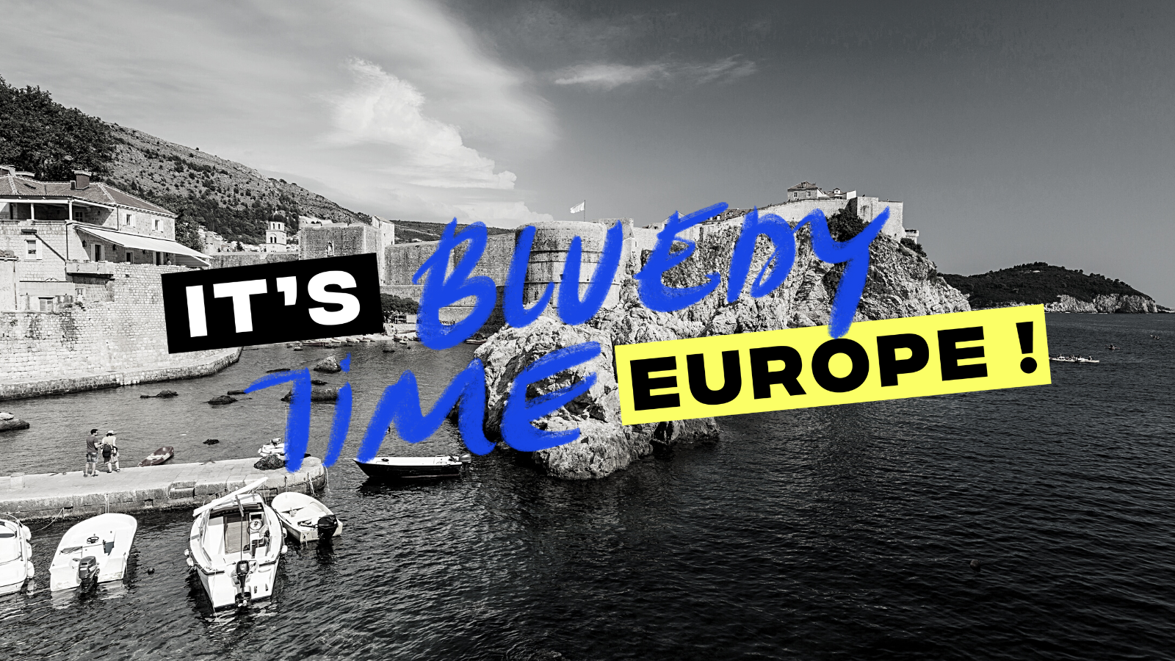

Option 3/
[OPEN TO EVERYONE] 🗣️This citizen-based consultation is looking for your ideas on how to better protect the #ocean 🌊 Click on the link to join the discussion 👉www.oceanvoice.eu #BlueUp24 #OurOcean
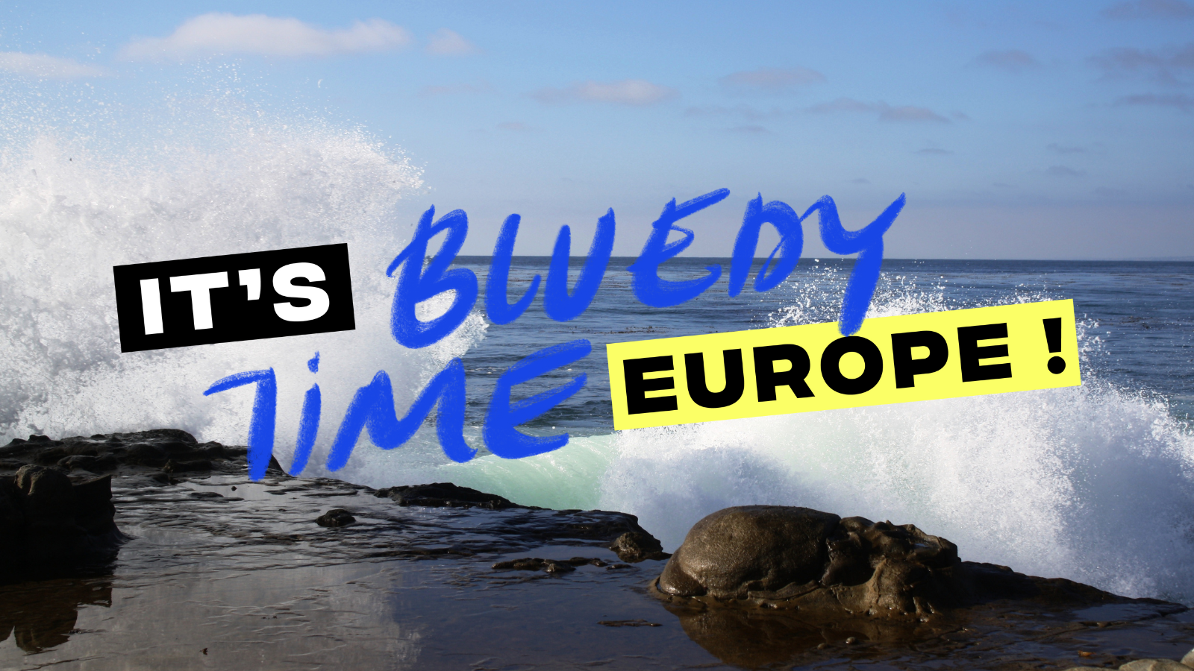

Option 4/
[WE NEED YOU🐠] Don't miss the opportunity to make your voice heard🔊 A coalition of NGOs has launched this consultation to collect all the ideas on #ocean protection & bring them to the #EU institutions 🌊You can play our part 👉 www.oceanvoice.eu #BlueUp24 #OceanCall

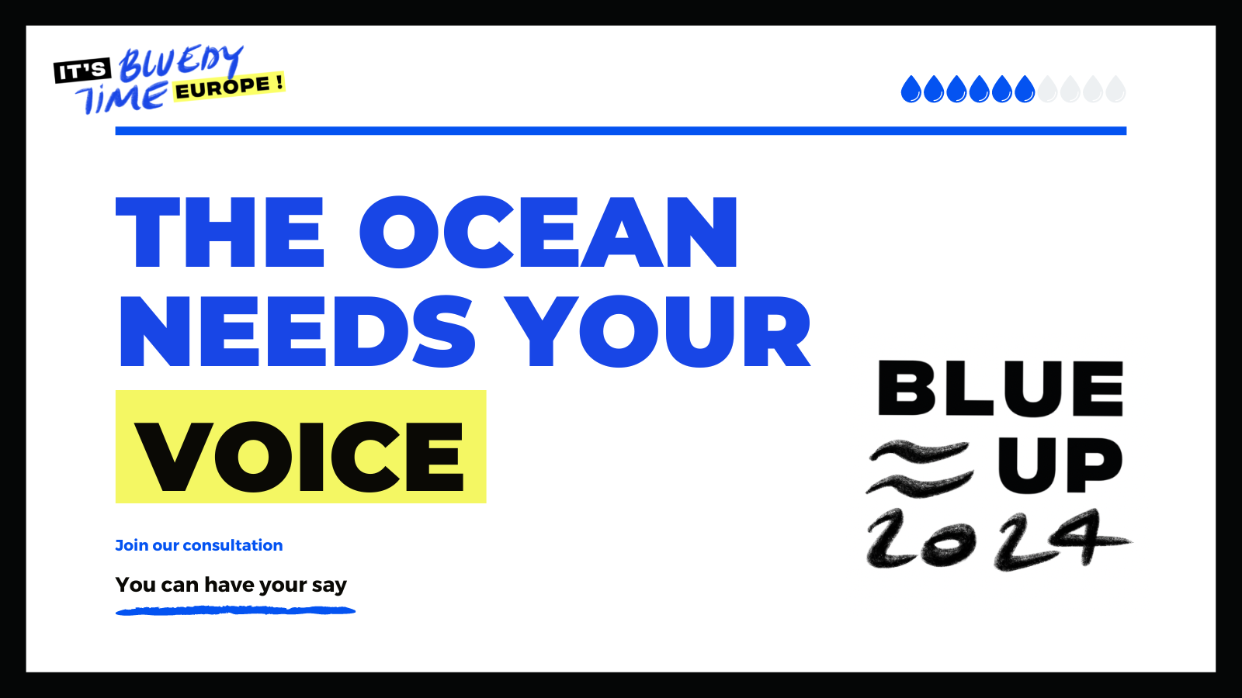

LinkedIn/Facebook posts

Option 1/

🔊 CALL TO ACTION 🔊
In 2024, Europeans will vote for their representatives for the next five years. With ever-increasing pressures on the environment, the years 2024-2029 will be five key years for the ocean, biodiversity and climate.
The largest ocean-related consultation is LIVE with the aim of giving voice to all #European citizens. Along with a number of ocean actors & NGOs, we need your inputs, ideas & suggestions as we believe it’s never too early to make your voice heard! 🌊
Make sure you are not missing out and participate now with your own ideas 💡 Click here 👉 www.oceanvoice.eu

[Tag supporting organisations on the post]
#BlueUp24 #OceanCall #OceanAction #OurOcean

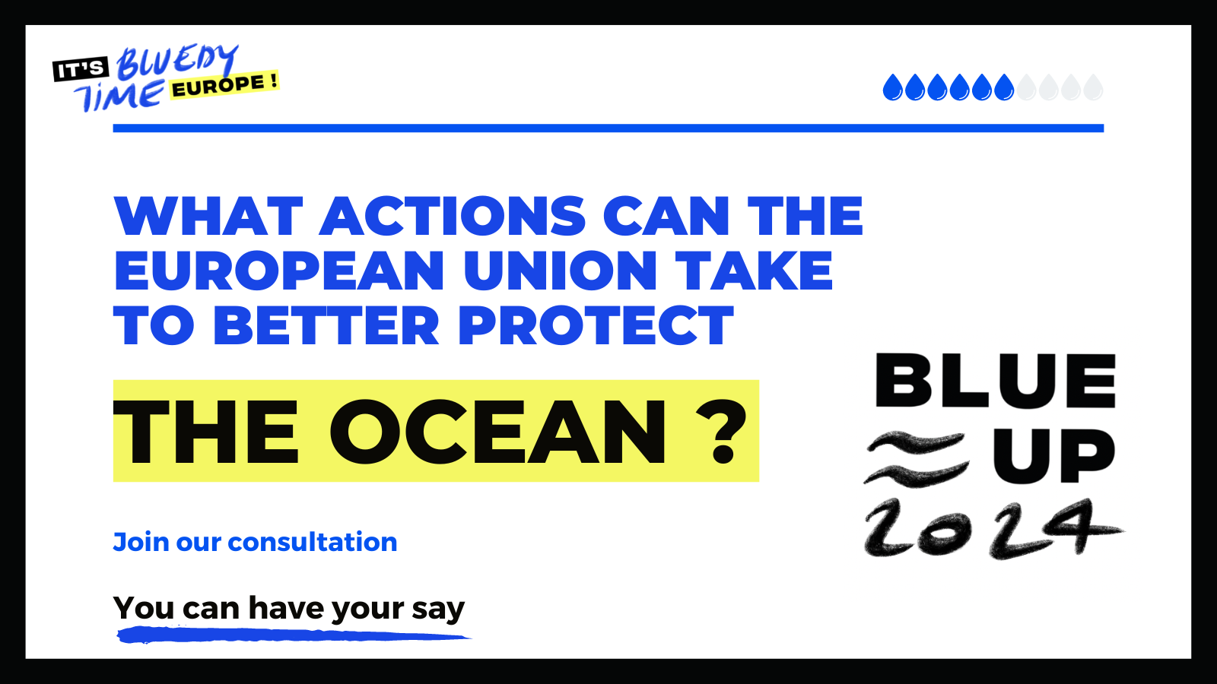

Option 2/

[It's Bluedy Time, Europe! 🌊]

From your point of view, what actions can the European Union take to better protect the Ocean?

📣 Participate in the biggest ocean-related consultation at European level, that will bring your demands on ocean issues directly to the European decision makers ahead of the 2024 EU elections.

⏳ The coming years will determine the future of our planet: the EU will take important decisions that will impact the Ocean. Whether it is on energy, plastic pollution, maritime transport or fishing –you name it. It is in our hands to bring the knowledge and our best ideas to those who will decide on these issues in the coming years.

🙌 Don't miss your chance to give your voice to the future of ocean protection and bring your thoughts to the EU institutions. 👉 www.oceanvoice.eu

#BlueUp24 #OceanCall #OceanAction #OurOcean

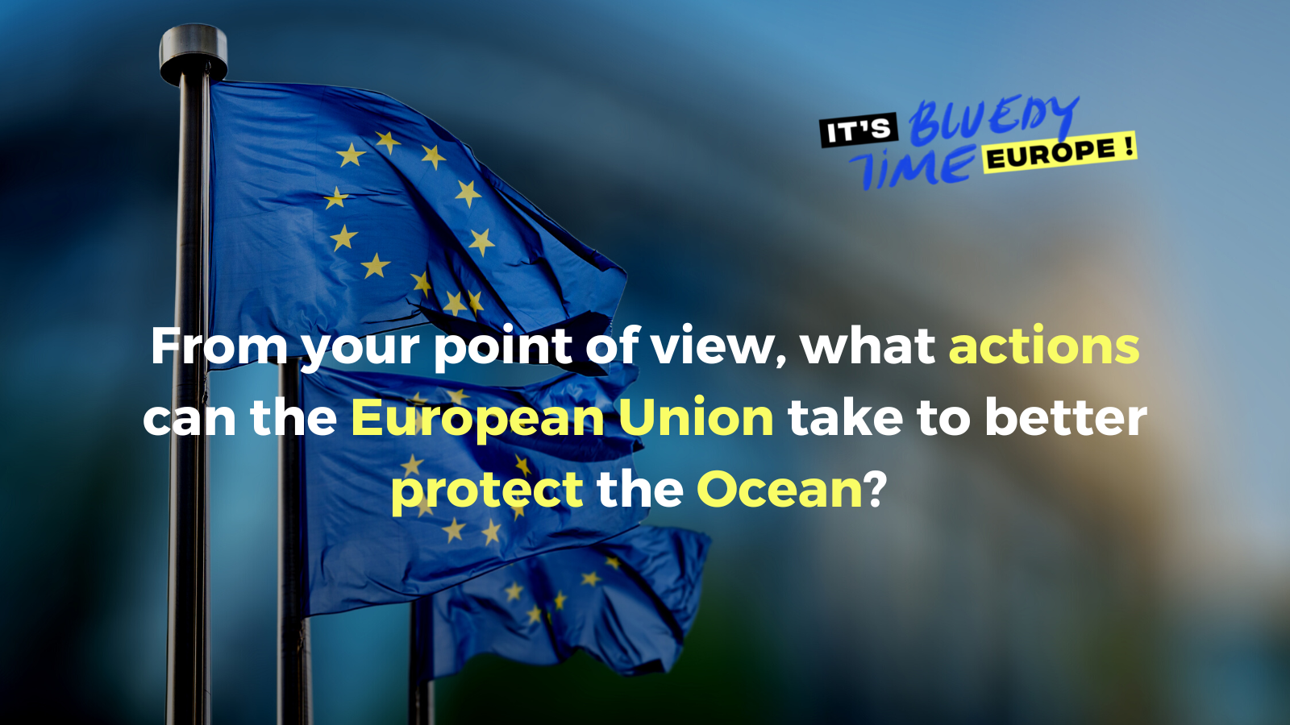

Instagram posts

[It's Bluedy Time, Europe! 🌊]

From your point of view, what actions can the European Union take to better protect the Ocean?

📣 Participate in the biggest ocean-related consultation at European level, that will bring your demands on ocean issues directly to the European decision makers ahead of the 2024 EU elections.

⏳ The coming years will determine the future of our planet: the EU will take important decisions that will impact the Ocean. Whether it is on energy, plastic pollution, maritime transport or fishing –you name it. It is in our hands to bring the knowledge and our best ideas to those who will decide on these issues in the coming years.

🙌 Don't miss your chance to give your voice to the future of ocean protection and bring your thoughts to the EU institutions 👉 Check the link in bio to take part !
[Add this link to bio : www.oceanvoice.eu]

#BlueUp24 #OceanCall #OceanAction #OurOcean

[Different options]:
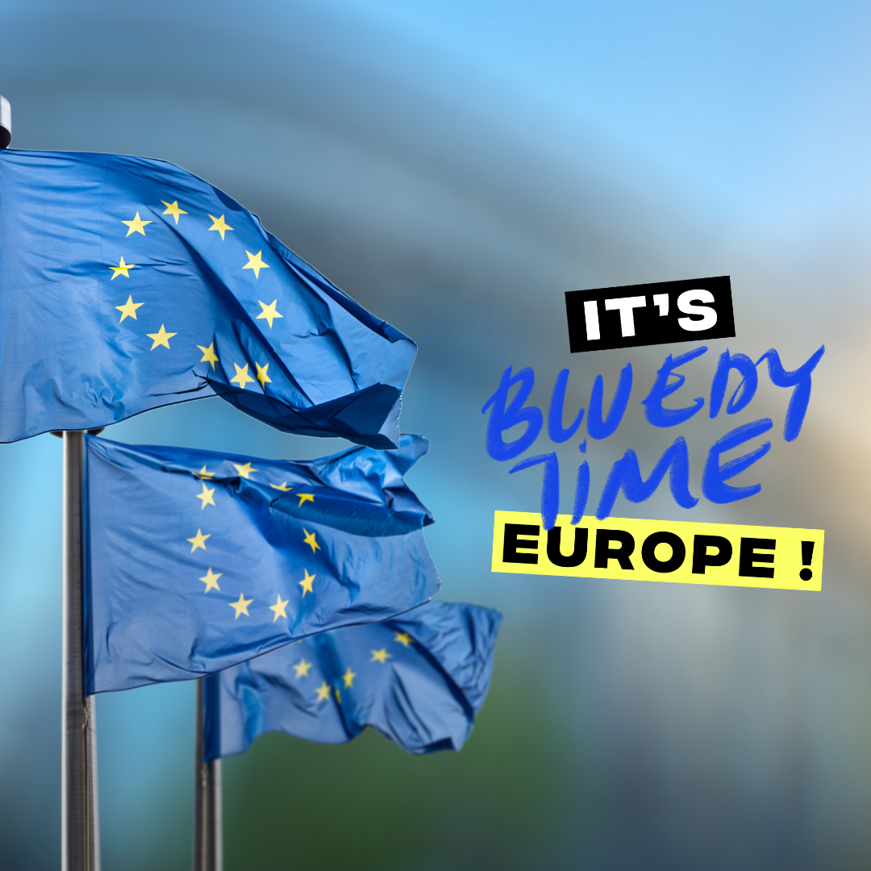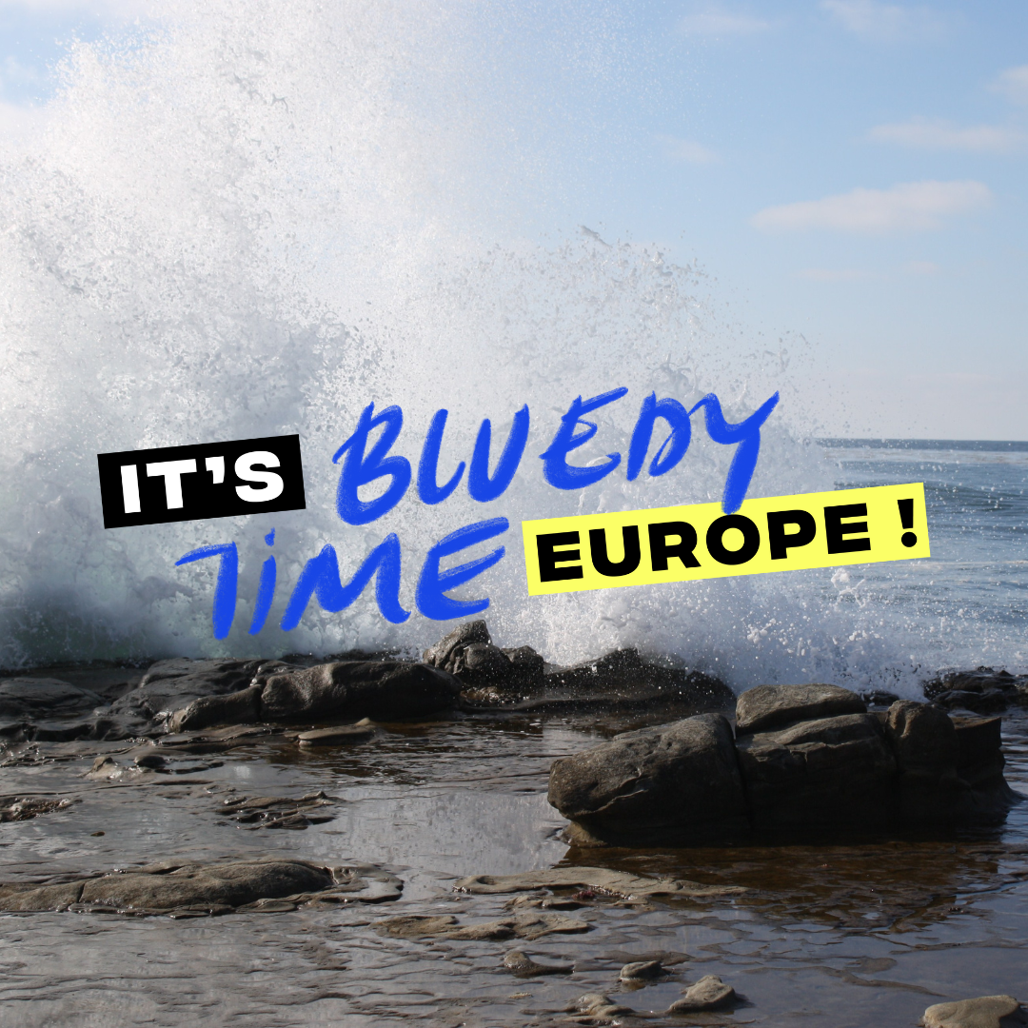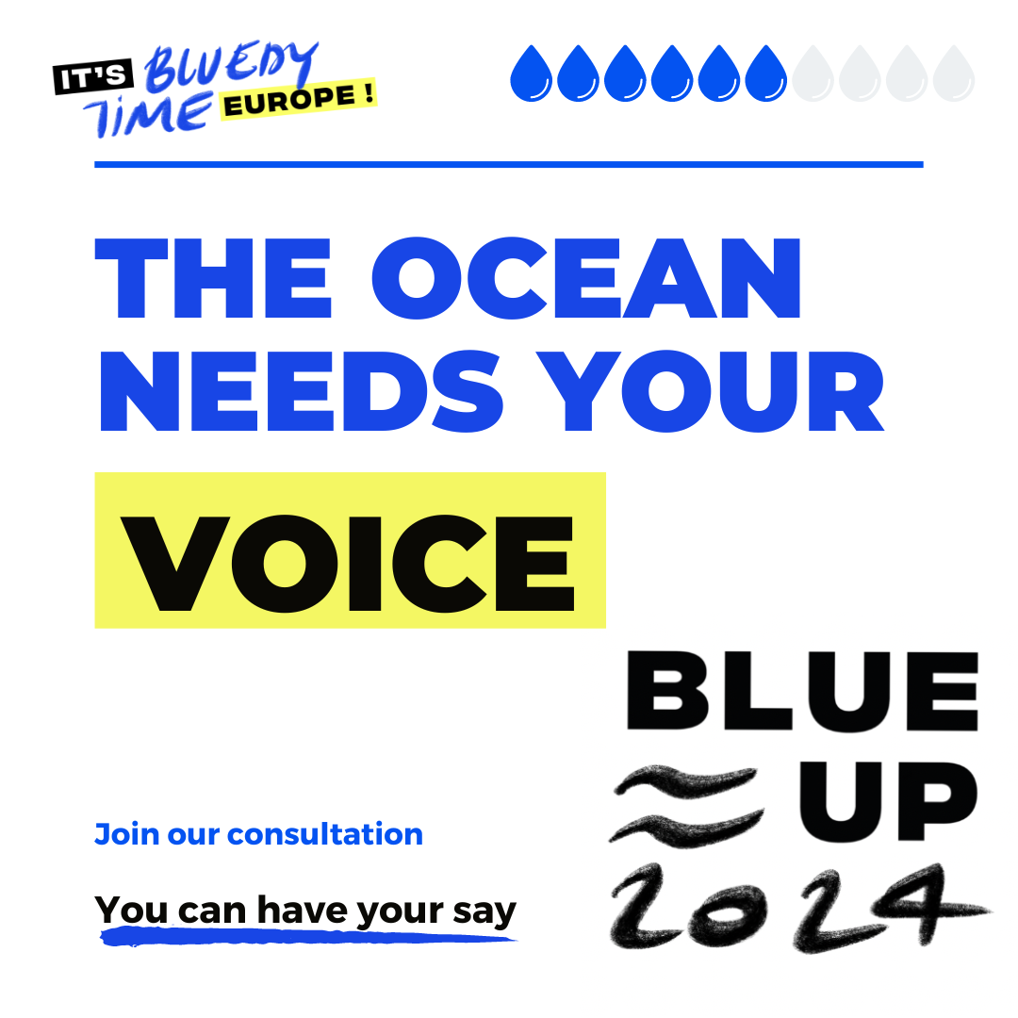
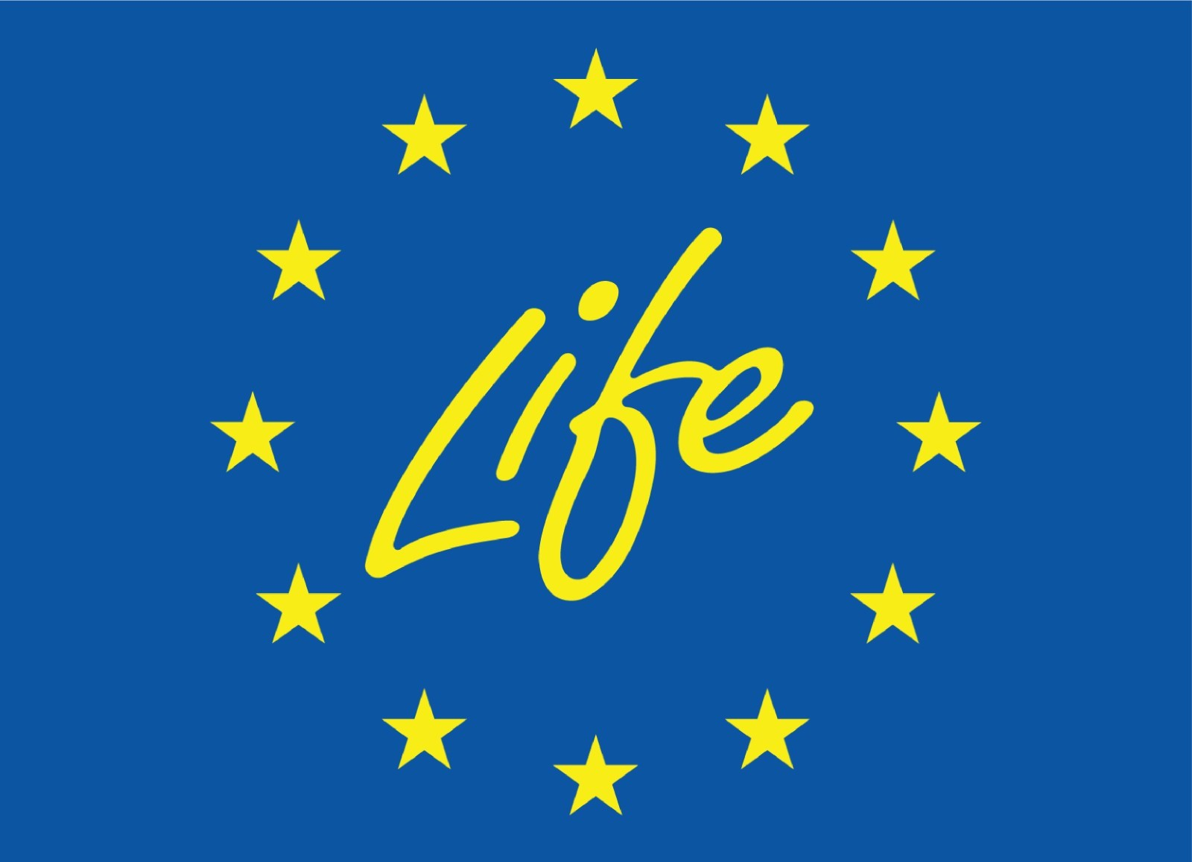
This project has received funding from the Life programme of the European Union. The European Commission's support for the production of this campaign does not constitute an endorsement of the contents, which reflect the views only of the authors, and the Commission cannot be held responsible for any use which may be made of the information contained therein.

